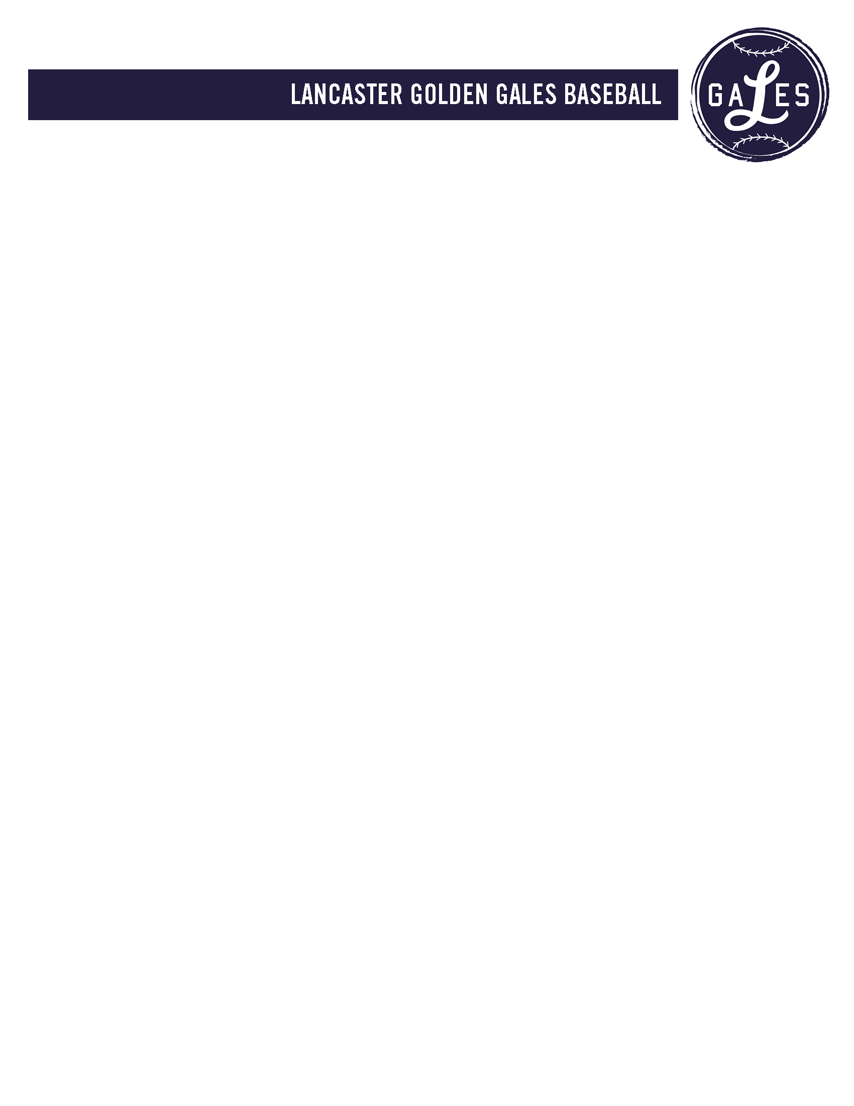

**LeaderBoard** (after 8 Events)

1st- Dryden (37pts)

2nd-Strang (35pts)

3rd- Barnette (29pts)

4th-Meszaros (24pts)

5th-Jones (23pts)

6th- Sines (19pts)

**2016 Huntington Park Challenge**

Event 8- Plate Holds

**1st Place (6pts)- Team Strang**

**2nd Place (5pts)- Team Meszaros**

**3rd Place (4pts)- Team Barnette**

**4th Place (3pts)- Team Dryden**

**5th Place (2pts)- Team Jones**

**6th Place (1pt)- Team Sines**

